Use-Case Realization Report (Design)
Update Lesson

Issue <1.0>
Revision History
Date | Issue | Description | Author
29/11/09 | 1.0 | Initial Version | Rajendran Kumaraguru

Table of Contents
1. Brief Description 4
2. Flow of Events 4
2.1 Standard Flow 4
2.2 Exception Flow 4
3. Interaction Diagrams 5
3.1 Sequence Diagram for Update Lesson 5
4. Participating Objects 5
5. Class Diagrams 6
5.1 Class Diagram for Update Lesson 6
6. Derived Requirements 6

Use-Case Realization Report (Design)
Update Lesson

Brief Description
Upon successful creation of the company, if any changes required then the portal admin will be able to perform the update lesson. In another case if there a change in the site then update operation will be performed by portal admin. This activity only during the validity period of the company.

Flow of Events

Standard Flow
- Portal Admin login in to the system.
- Editing the uploaded site information for the particular company, click “EditSite” button..
- Loading the company details
- Load the stylesheet which is used for particular company
- Validate fields will be validating the data while updating the lesson.
- Update the Site
- Update the module master.
- Upon successful update of lesson the message will be shown back to the portal admin.

Exception Flow
  - When there is no particular lesson is not available then there should be an exception will throw lesson doesn’t exist.

Interaction Diagrams

Sequence Diagram for Update Lesson
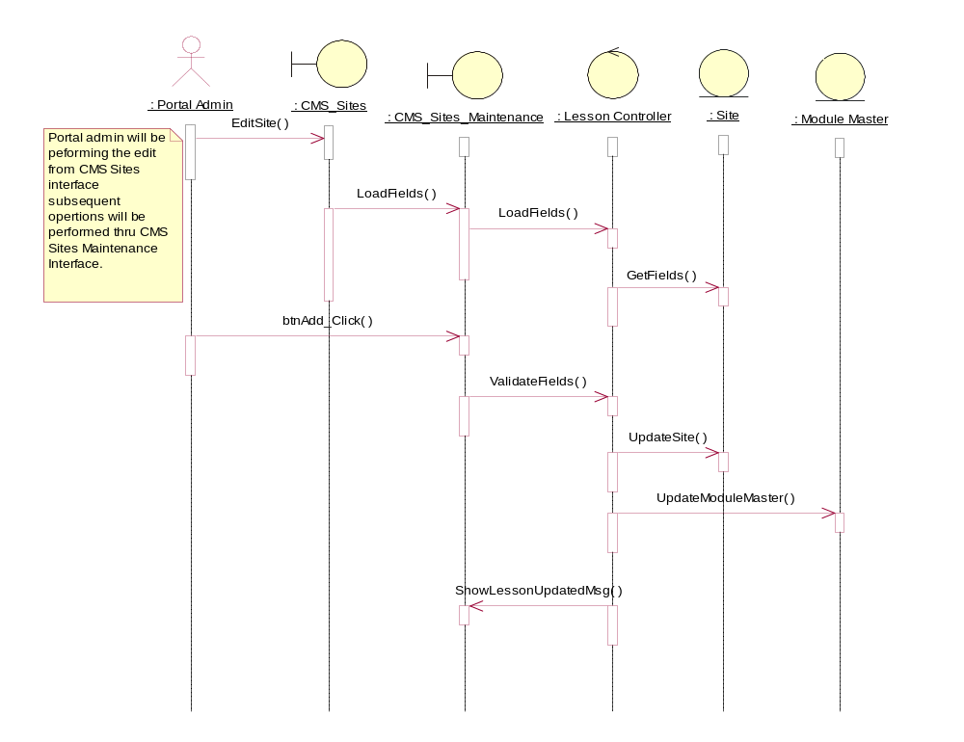

Participating Objects
: CMS_Sites

: CMS_Sites_Maintenance

: Lesson Controller

: Module Master

: Portal Admin
This is the super user of the system.
: Site

Class Diagrams

Class Diagram for Update Lesson
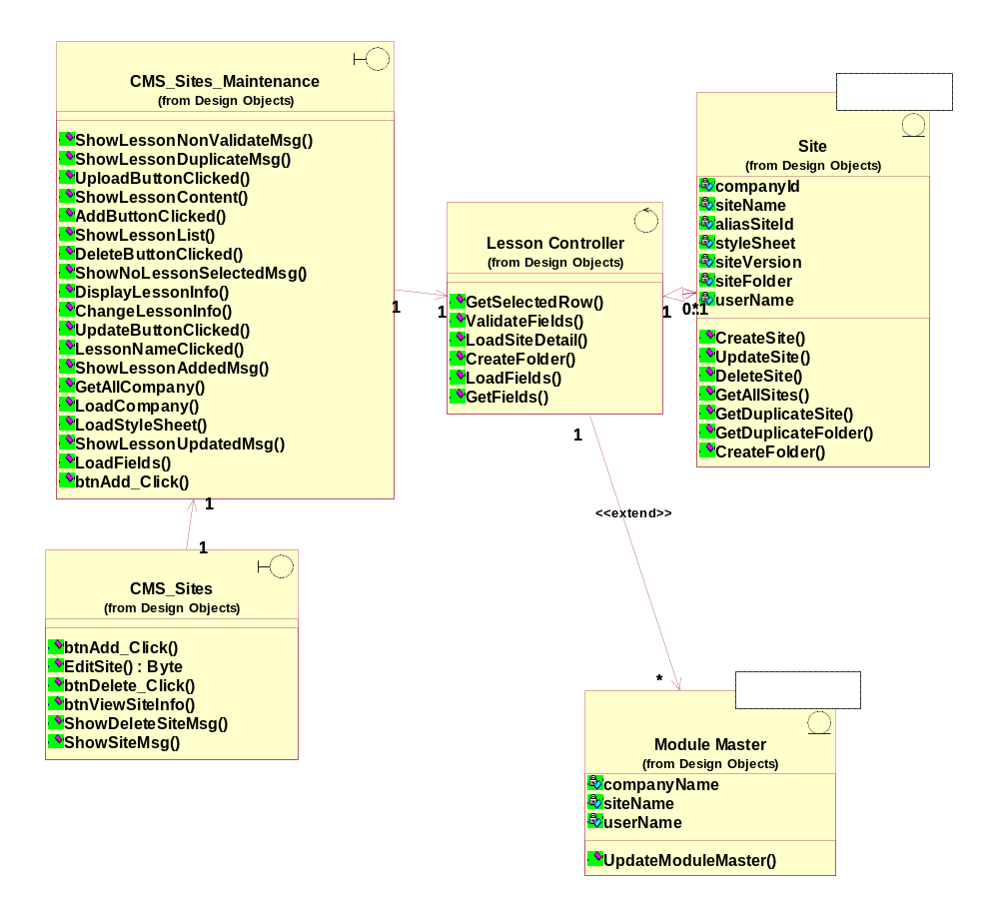

Derived Requirements
[enter the derived requirements here]

